Project Step 4 Draft

Group 46: Joshua Cicchinelli, Mauricio Marin Gutierrez, and Son Thai Do Nguyen

URL Link

http://classwork.engr.oregonstate.edu:1995

Feedback by the peer reviewer
Draft 2
Skyla Chen:
Hello Team 46!
- Your review should provide helpful and insightful answers to the following questions:
- Does the overview describe what problem is to be solved by a website with DB back end? If yes, summarize. If not, what changes would better support describing the problem to be solved?
  - I think your guy’s overview does a great job at explaining how your database will manage inventory for a library. I think that you can implement a bit more strength in by mentioning more specific ideas like tracking books that are overdue or what to do with misplaced items, etc.
- Does the overview list specific facts? If yes, summarize what the facts illustrate about the proposed DB solution. If not, what facts would better support illustrating the scope and scale of the proposed DB solution?
  - Yeah, I think the over does lists pretty specific facts like the numbers provided as this helps show that this is indeed a mid-scale library database.
- Are at least four entities described, and does each one represent a single idea to be stored as a list? If yes, summarize. If not, based on the course material, what changes can you suggest to improve?
  - Yes, at least four entities are described, each doing a great job representing a clear concept.
- Does the outline of entity details describe the purpose of each, list attribute datatypes and constraints, and describe relationships between entities? If yes, summarize. If not, based on the course material, what changes can you suggest to improve?
  - Yes, the outline of entity details describe the purpose with the appropriate and specific datatypes
- Are 1:M relationships correctly formulated? Is there at least one M:M relationship? Does the ERD present a logical view of the database? If yes, summarize. If not, based on the course material, what changes can you suggest to improve?
  - Yes the ERD shows the 1:M relations.
    - Book → BookCopies
    - Patrons → Loans
    - BookCopies → Loans
  - As well as M:M relations:
    - Books <-> Authors
    - Books <->Genres
- Is there consistency in a) naming between overview and entity/attributes b) entities plural, attributes singular c) use of capitalization for naming? If yes, summarize. If not, based on the course material, what changes can you suggest to improve?
  - Looking it over, I’d say there is a bit of inconsistency in capitalization, where the names in the ERD are shown in plain text rather than camelCase. But an easy fix.
All is original, besides the questions which were provided in the review assignment.

Sammy Alyooi16h:
- Group 46 overview describes the problem set and shows that it can be solved by a web application with a database backend. I think the library system involves many entities with attributes of different data types and domains. The overview discusses storing, retrieving, altering, and presenting data, all of which I believe can be implemented using a model-view-controller or MVC concept website and database with CRUD operations and API endpoints to perform various operations. The overview of the library system specifies some of the main facts and transactions like number of books, registered members, central database, and record keeping.
- There are six entities, with master entities such as Books, Patrons, and Authors. Some entities have primary keys and 1:M relationships, with their PK being referenced in other entities as FK, as described in Chapters 11 and 16 of the textbook.
- Each entity has a short description that highlights its purpose. For example, the Patrons entity records members or customers of the library who can borrow materials. Loans, on the other hand, tracks book checkout transactions by patrons and records fees, book status, and transaction dates. The entities’ 1:M relationships are described with good clarity. Patrons has a 1:M relationship with Loans, implemented with PatronID being referenced as FK inside Loans. Also, BookCopies has a 1:M relationship with Loans, where the BookCopies attribute CopyID is used as FK inside Loans. I think this relationship needs a bit more explanation to highlight whether it takes place over a period of time or represents a single transaction.
- There is a good level of consistency between the project overview and the entities and attributes. One thing that stood out was that I only saw references to physical book copies, but no mention of digital copies, magazines, or other library materials.
All my work is original.

Santos Garcia Santiago:
Hello everyone,
- The drafts looks great and after reviewing here is some of my comments and feedback of the draft:
- This overview describes efficiently that the library will keep inventory of its maximum 43,000 books and it will be able to serve to a maximum of 25,000 members with a website and database and this way library does not rely on manual tools for this task, thus making the use of the library easier and quicker for clients and employees.
- Overall, the outline of entities and each of their attributes describes their relationships, the datatypes and their constraints accurately and have consistency across each of them. One update I would make is to the ER Diagram to include the list of attributes in each table and the relationship between those attributes as Primary and Foreign Keys. As well as adding the intersection tables for BookAuthors and BookGenres for the Many-to-Many relationships. Other than that the draft is following the metrics for the project.

The review and all the feedback was completed and original from myself.
Good Luck on the Term, Santos

Lindsey Clement:
I like how you separated book titles from physical copies and tracked loans at the copy level. Nice work!

- Jonathan Salfen:
- Does the overview describe what problem is to be solved by a website with DB back end? If yes, summarize. If not, what changes would better support describing the problem to be solved?
  - The database will manage a book inventory for a medium size library.
- Does the overview list specific facts? If yes, summarize what the facts illustrate about the proposed DB solution. If not, what facts would better support illustrating the scope and scale of the proposed DB solution?
  - Manages up to 43,000 books.
  - Will serve 15-25k registered members.
  - Software will be used by support staff and clients.
  - Access allowed to the software 24/7.
- Are at least four entities described, and does each one represent a single idea to be stored as a list? If yes, summarize. If not, based on the course material, what changes can you suggest to improve?
  - Books - Records the details of books in the library
  - Patrons - Records library members who can borrow materials.
  - Loans - Tracks all book checkout transactions between patrons and book copies,
  - recording dates, fees and status
  - Authors - Stores information about authors of the book(s)
  - Genres - Stores a list of genres that can be associated with books
  - BookCopies - Track the physical copy of a book (Some book titles can have multiple
  - copies)
- Does the outline of entity details describe the purpose of each, list attribute datatypes and constraints, and describe relationships between entities? If yes, summarize. If not, based on the course material, what changes can you suggest to improve?
  - Yes mostly, however there are a couple things to note:
    - Books table - How are books with same title/publication year/publisher to be handled with regards to varying ISBNs? (i.e. paperback vs hardcover have different ISBNs). It might be useful to have an additional field in Books that describes that difference (hardcover, paperback, special edition, etc.)
- Are 1:M relationships correctly formulated? Is there at least one M:M relationship? Does the ERD present a logical view of the database? If yes, summarize. If not, based on the course material, what changes can you suggest to improve?
  - 1:M relationships are correctly implemented via foreign keys:
    - Books → BookCopies
    - Patrons → Loans
    - BookCopies → Loans
  - M:N relationships are appropriately resolved using intersection tables:
    - Books ↔ Authors via BookAuthors
    - Books ↔ Genres via BookGenres
  - Improvement suggestions for the ERD:
    - Show participation (optional or mandatory).
    - Including fields listed under each table would make the diagram more usable.
    - Show intersection tables BookAuthors and BookGenres.
- Is there consistency in a) naming between overview and entity/attributes b) entities plural, attributes singular c) use of capitalization for naming? If yes, summarize. If not, based on the course material, what changes can you suggest to improve?
  - Naming looks consistent and appropriate.
  - Improvement Suggestion:
    - The name BookCopies is confusing and doesn’t immediately describe the table use case (it makes me think the Books table is tracking the main book, and the BooksCopies is tracking photocopied copies). Consider something more specific, like BookPhysicalCopies, PhysicalBooks, or rename both Books and BooksCopies to: Titles or Works and Items or PhysicalItems (separating the concepts of abstract intellectual work and tangible inventory).
- Prompt used to review last 3 questions from the writing prompt for the assignment [from https://canvas.oregonstate.edu/courses/2031764/assignments/10323333?module_item_id=26243383]. AI responses were integrated with reviewer thoughts.
  - Prompt: “look over the attachment, and help fill out the following questions from the perspective of a database professor [3 questions inserted here]. [PDF of draft from Group 46 attached]”
  - Date: 1/19/26
  - AI Source URL: https://chatgpt.com/
- Prompt used to formulate improvement suggestion for last question from the writing prompt from https://canvas.oregonstate.edu/courses/2031764/assignments/10323333?module_item_id=26243383. AI responses were integrated with reviewer thoughts.
  - Prompt: “how could you separate the ideas of physical books in the library and the electronic classification of them? I'm trying to find better names for books and BooksCopies”
  - Date: 1/19/26
  - AI Source URL: https://chatgpt.com/

Draft 3
Zachary Sherman
- Does the UI utilize a SELECT for every table in the schema?
  - Right now, it doesn’t look like any selects are utilized in the UI. However, Selects are present in the DML file and appear to cover every table.
- Does the UI implement an INSERT form for at least one table in the schema?
  - Yes, there is an insert form for every table and page. It also looks like you have the procedures defined in the DML.
- Does the UI have at least one DELETE for any one entity?
  - I couldn’t find a delete option on the UI or the DML. I think the easiest implementation is deleting a loan record on item return.
- Does the UI have at least one DELETE that will remove things from a M:M relationship?
  - No, that is not currently implemented in the UI or the DML.
- Is there at least one UPDATE form in the UI for any one entity?
  - Yes, every table has an update form.
- Is there at least one UPDATE form in the UI to modify an M:M relationship?
  - Yes, right now, there is an update option for every single relationship.
- Do you have any other suggestions for the team to help with their HTML UI? For example, using AS aliases to replace obscure column names such as fname with First Name.
  - When constructing the views, I would recommend using aliases for the attribute names. The tables on the UI currently have that setup, but the DML does not. I also recommend not displaying IDs unless explicitly helpful to the user. In situations where an ID is a foreign key, I find it more readable to replace that with an attribute from the foreign entry instead. For example, instead of showing CustomerID = 3, have Customer= “Dave Thomas”.

This review was entirely my own.

Cody Strehlow
- Does the UI utilize a SELECT for every table in the schema? In other words, data from each table in the schema should be displayed on the UI. Note: it is generally not acceptable for just a single query to join all tables and displays them.
  - You do have SELECT statements for every table in the schema in your DML, and you have provided functionality to SELECT data from each table in the UI, but there isn't any actual data showing up for any of the tables, some static sample data would be nice to see how the page would look populated with data.
- Does the UI implement an INSERT form for at least one table in the schema? In other words, there should be UI input fields that correspond to at least one table.
  - Yes, all of the pages include INSERT forms for the tables :)
- Does the UI have at least one DELETE for any one entity? In other words, is there a form/link/button that will allow the deletion of a row in at least one table?
  - I don't see any DELETE buttons on any of the pages in the UI, although you do have them in your DML.
- Does the UI have at least one DELETE that will remove things from a M:M relationship? In other words, if an order is deleted from the Orders table, it should also delete the corresponding rows from the OrderDetails table, BUT it should not delete any Products or Customers.
  - Again, not in the UI, but the functionality is included in your DDL via ON DELETE CASCADE.
- Is there at least one UPDATE form in the UI for any one entity? In other words, in the case of Products, can productName, listPrice, qtyOnHand, e.g. be updated for a single ProductID record?
  - Yes all of your table's include an UPDATE form in the UI.
- Is there at least one UPDATE form in the UI to modify an M:M relationship? In other words, does the UPDATE allow the user to select a different foreign key value to update the intersection table with?
  - There isn't a page for either BookAuthors or BookGenres, so there's no UPDATE form that would allow a user to select a different bookID, authorID, or genreID in either intersection table. But, similar to the other things missing from your UI, you do have the functionality in your DML.
- Do you have any other suggestions for the team to help with their HTML UI? For example, using AS aliases to replace obscure column names such as fname with First Name.
  - There's a slight inconsistency between your sample data in the DDL and the available options for the "Select Media Type" drop down on the Books page. Your sample data lists the bookMedia as "Physical" while there are only options for "Hardback", "Paperback", "E-book", and "Audio" in the dropdown. Overall your code is looking great, excited to see your UI when it's complete!

This review is entirely my own work

Cameron Brooks
Hi Joshua, Mauricio, and Son,
  - The library database has a solid schema design — 8 tables with two proper M:M relationships (Books↔Authors via BookAuthors, Books↔Genres via BookGenres) and a well-modeled Loans system. Here's my detailed review:
  - SELECT for every table: Yes — all 8 tables (Books, Patrons, Authors, Genres, BookCopies, Loans, BookAuthors, BookGenres) have their own SELECT queries. The queries for BookCopies, Loans, and the junction tables use JOINs to display human-readable data, which is a nice touch.
  - INSERT for at least one table: Yes — INSERT statements exist for all 8 tables in the DML, and INSERT forms are visible in the UI.
  - DELETE for any one entity: Yes — DELETE statements are present in the DML for all 8 tables (e.g., DELETE FROM Books WHERE bookID = @bookIDInput). The PDF screenshots also show Delete buttons on every table row. I want to note that previous reviewers stated DELETEs were missing from the DML and/or UI, but looking at both the SQL and the screenshots, they appear to be there.
  - DELETE for M:M relationship: Yes — this is well handled. The DDL uses ON DELETE CASCADE on both foreign keys in BookAuthors and BookGenres, so deleting a Book will automatically remove its entries from both junction tables without affecting the Authors or Genres themselves. There are also direct DELETE queries for BookAuthors and BookGenres to remove individual associations. The Loans table uses ON DELETE RESTRICT on both copyID and patronID, which is a smart choice — it prevents accidentally deleting a Patron or BookCopy that still has active loan records.
  - UPDATE for any one entity: Yes — all 8 tables have UPDATE statements in the DML.
  - UPDATE for M:M relationship: Yes — both BookAuthors and BookGenres have UPDATE queries that allow changing the foreign key values. For example, UPDATE BookAuthors SET authorID = @newAuthorIDInput WHERE bookID = @bookIDInput AND authorID = @oldAuthorIDInput lets you reassign a book to a different author within the junction table.
- Suggestions for improvement:
  - Junction table UI doesn't seem to use the JOIN queries yet: The DML has nice JOIN-based browse queries for BookAuthors and BookGenres that display book titles and author/genre names. However, the screenshots show these tables still displaying only raw IDs (bookID 1, authorID 1, etc.). Make sure the UI is wired to use those JOIN queries so users see "Harry Potter and the Sorcerer's Stone — J.K. Rowling" instead of "1 — 1". Same issue with the Loans table showing raw copyID and patronID numbers.
  - Minor doc/DDL mismatch on phone: The database outline says phone: VARCHAR(10) but the DDL creates it as VARCHAR(12). Worth reconciling — VARCHAR(12) is actually better if you ever want to store formatted numbers with dashes (e.g., 541-555-2001).
  - Consider ENUM or a lookup table for bookMedia: Right now bookMedia is a freeform VARCHAR(50). Since the values are likely a small fixed set (Physical, Digital, Audiobook), an ENUM like you used for Loans.status would prevent inconsistent entries like "physical" vs "Physical" vs "PHYSICAL". Alternatively, a small MediaTypes reference table would work.
  - Search/filter queries for scale: Your overview mentions serving 43,000 books and 15,000–25,000 patrons. The current DML only has browse-all queries (SELECT ... ORDER BY). For that scale, consider adding a search query, e.g., SELECT ... FROM Books WHERE title LIKE CONCAT('%', @searchInput, '%'), which would make the UI much more practical at scale.
  - Overall, this is one of the more complete implementations I've seen — the DML covers full CRUD for every table including the junction tables, the JOINs and dropdowns are well thought out, and the cascade/restrict strategy is sound. The main areas to tighten up are making sure the UI is actually using those JOIN queries and the minor doc inconsistencies.

AI tools were used to help structure and draft this review per the course Code Citation Tips. The technical analysis, observations, and suggestions are based on my own reading of the DDL, DML, PDF documentation, and UI screenshots.

Draft 4

Actions based on the feedback
- Draft 2
  - Updated capitalization so that terms were consistent throughout due to Skyla’s and Jonathan’s suggestion.
  - Followed Sammies tip to allow for other types of books.
  - Fleshed out the relationship between BookCopies and Loans according to Sammy’s suggestion.
  - Used Santos’s suggestion to make the ERD better.
- Draft 3
  - Followed Cody Strehlow advice and added junction tables
  - Thai-Binh Guerreiro’s suggestion to change media to ENUM was followed.
  - Cameron Brooks helped by finding a correction for phone VARCHAR mismatch.
- Draft 4

Upgrades to the Draft version
- Draft 2
  - Added an attribute in table Books to allow for the medium with which the book is (digital, physical, etc.); “bookMedia: VARCHAR (50), not NULL”.
  - Added “Each row is a separate transaction showing what happens over time.” to clarify the Loan to BookCopy relationship.
  - Included the list of attributes in each table and the relationship of the Keys.
  - Consider the relationship of ENUM vs VARCHAR for some attributes
  - Updated phone to have 10 characters to maintain consistency.
- Draft 3
  - Created Git repository for teamwork coordination
  - Implemented UI backend as well as CRUD framework
  - Included URL to home page index.
  - Adjusted route handler to add sample data to pages this caused the Delete button to appear.
- Draft 4
  - Created PL.sql for Stored Procedures
  - Added 2 procedures to calll
    - reset_procedure (literally just DDL + sample Data)
    - delete_demo_loan (deletes a specific loan to demo resetting
  - Adjusted DDL (Schema/Database Structure) and DML(CRUD Operations) so they are more in line with project specs

Project Outline and Database Outline, ERD Schema & Sample Data Updated Version
Overview:
This library database will keep an inventory of all the books that a medium size library holds, up to 43,000 books. It will be able to serve 15,000-25,000 registered members,with a centralized database. Furthermore, this system will store data on each of the books as well as facilitate a record of transactions that patrons will be able to perform when they borrow books. Clients will be able to use this software at the same time; 24/7. Without this, the library would have to rely on fragmented or manual tools.

Database Outline:
- Books- Records the details of books in the library
  - bookID: INT, auto_increment, unique, not NULL, PK
  - ISBN: VARCHAR(13), not NULL, UQ
  - title: VARCHAR(255), not NULL
  - publicationYear: YEAR
  - publisher: VARCHAR(100)
  - bookMedia: ENUM('Hardcover','Paperback','E-Book','Audio'), not NULL

  - Relationships:
    - A M:N relationship between Books and Authors is implemented using BookAuthors intersection table.
    - A M:N relationship between Books and Genres is implemented using the BookGenres intersection table.
    - A 1:M relationship between Books and BookCopies is implemented with bookID as a FK inside of BookCopies

- Patrons- Records library members who can borrow materials.
  - patronID: INT, auto_increment, unique, not NULL, PK
  - libraryCardNumber: VARCHAR(20), not NULL, UQ
  - firstName: VARCHAR (50), not NULL
  - lastName: VARCHAR (50), not NULL
  - email: VARCHAR (100), not NULL, UQ
  - phone: VARCHAR (12)

  - Relationship:
    - A 1:M relationship between Patrons and Loans is implemented with patronID as a FK inside of Loans.

- Loans- Tracks all book checkout transactions between patrons and book copies, recording dates, fees and status. Each row is a separate transaction showing what happens over time.
  - loanID: INT, auto_increment, unique, not NULL, PK
  - copyID: INT, not NULL, FK
  - patronID: INT, not NULL, FK
  - checkoutDate: DATE, not NULL, default (CURRENT_DATE)
  - dueDate: DATE, not NULL
  - returnDate: DATE, NULL
  - lateFee: DECIMAL (5,2), default 0.00
  - status: ENUM (‘Active’, ‘Returned’, ‘Overdue’, ‘Lost’), default ‘Active’

  - Relationships:
    - A 1:M relationship between Patrons and Loans is implemented with patronID as a FK inside of Loans.
    - A 1:M relationship between BookCopies and Loans is implemented with copyID as FK inside of Loans.

- Authors- Stores information about authors of the book(s)
  - authorID: INT, auto_increment, unique, not NULL, PK
  - firstName: VARCHAR(50), not NULL
  - lastName: VARCHAR(50), not NULL
  - birthYear: SMALLINT, NULL

  - Relationship(s):
    - A M:N relationship between Books and Authors is implemented using the BookAuthors intersection table.

- Genres- Stores a list of genres that can be associated with books
  - genreID: INT, auto_increment, unique, not NULL, PK
  - genreName: VARCHAR(50), unique, not NULL

  - Relationship(s):
    - A M:N relationship between Books and Genres is implemented using the BookGenres intersection table.

- BookCopies- Track the physical copy of a book (Some book titles can have multiple copies)
  - copyID: INT, auto_increment, unique, not NULL, PK
  - bookID: INT, not NULL, FK
  - acquisitionDate: DATE, not NULL
  - condition: VARCHAR(20), not NULL
  - location: VARCHAR(50), not NULL
  - status: VARCHAR(20), not NULL

  - Relationship(s):
    - A 1:M relationship between Books and BookCopies is implemented with book ID as a FK inside of BookCopies

- BookAuthors- A join table to associate books and authors
  - bookID: INT not NULL, PK, FK
  - authorID: INT not NULL, PK, FK

  - Relationship(s): A M:N relationship between Books and Authors, where a book may have multiple authors and an author may have written multiple books.

- BookGenres- A join table to associate genres and books
  - bookID: INT not NULL, PK, FK
  - genreID: INT not NULL, PK, FK

  - Relationship(s): A M:N relationship between Books and Genres, where a book may have multiple genres and a genre may have multiple books as part of it.

Entity Relationship Diagram:
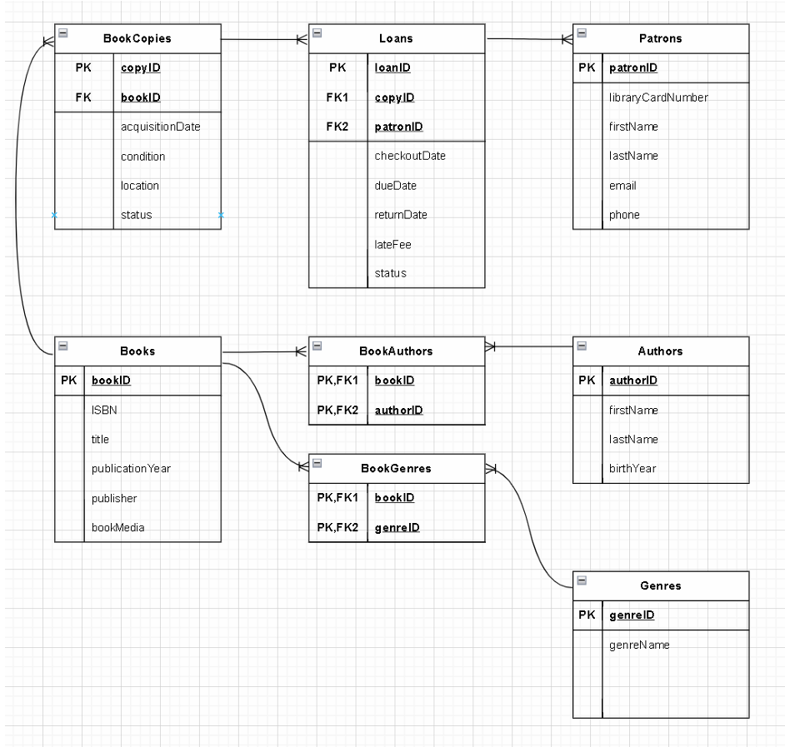

Schema Diagram:
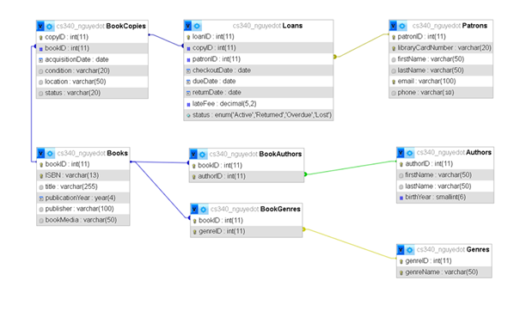

Sample Data:
Books
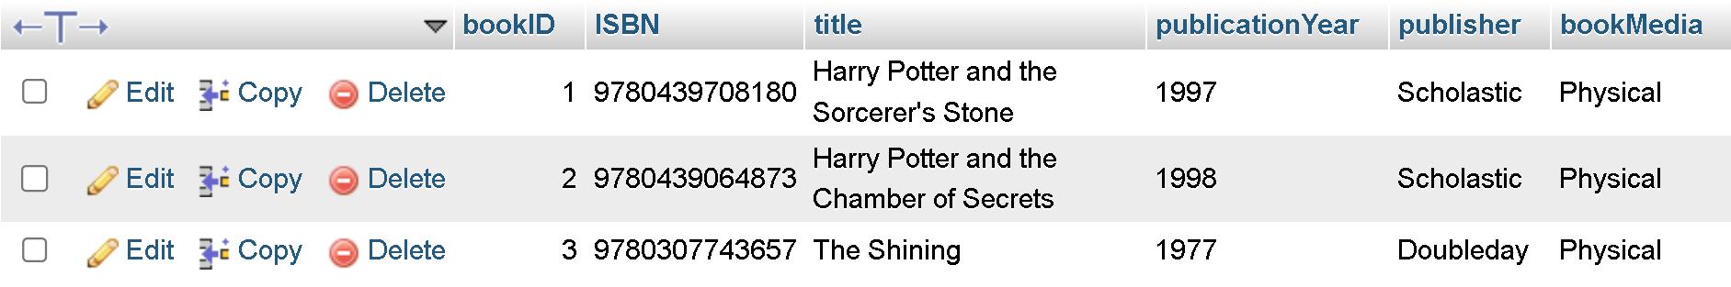
Patrons
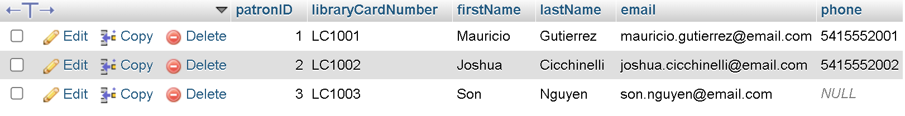
Authors
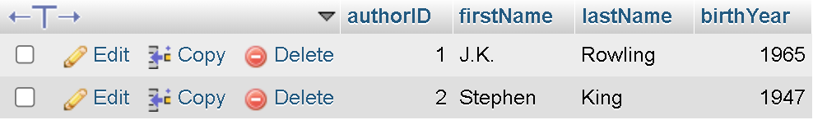
Genres
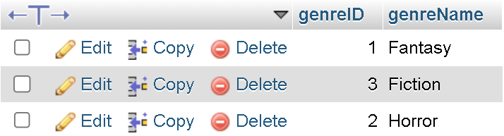
BookCopies
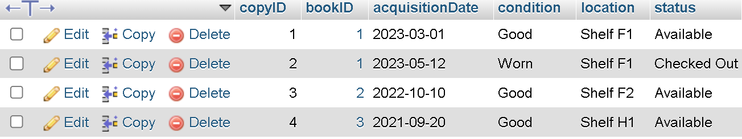
BookAuthors
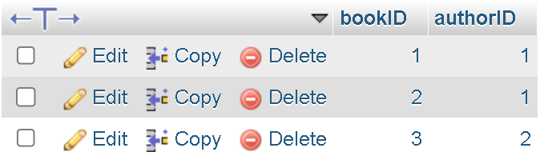
BookGenres
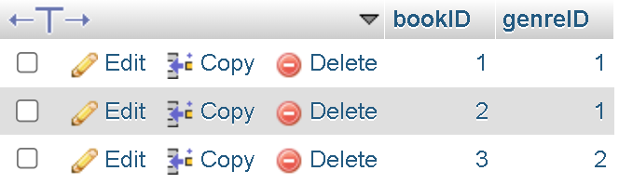
Loans
